DBMS Assignment 6
(Exercise on updating records in table)
Create Client_master with the following fields (ClientNO, Name, Address, City, State, bal_due) ( a ) Insert five records 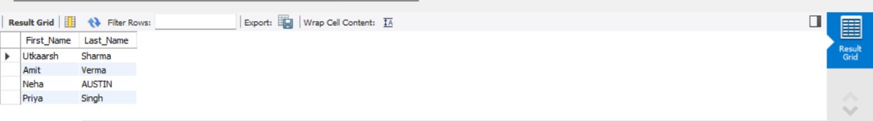

( b ) Find the names of clients whose bal_due> 5000 and Change the bal_due of ClientNO “ C123” to Rs. 5100 ( d ) Change the name of Client_master to Client12. 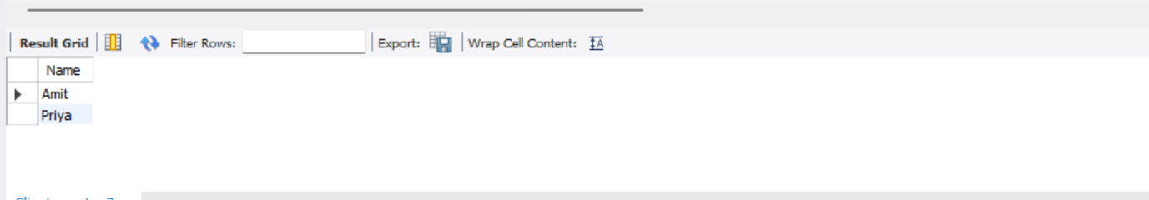

( e ) Display the bal_due heading as “BALANCE”
